

Cairo University   
Faculty of Engineering

Phase 2 Report

CMPS205 – Computer Graphics

Stardust Siege

|  |  |
| --- | --- |
| **Name** | **ID** |
| Abdelrahman Mohamed Ezzat | 1190158 |
| Farah Mohamed Abdelfatah | 1190176 |
| Salma Ahmed Mahfouz | 1190253 |
| Ziad Ahmed Hamed | 4200002 |

# **Workload**

|  |  |
| --- | --- |
| Abdelrahman Mohamed Ezzat | Postprocessing  Score  Tilting logic  Sound effects |
| Farah Mohamed Abdelfatah | Game Logic |
| Salma Ahmed Mahfouz | Light |
| Ziad Ahmed Hamed | Light |

# **Screenshots**

**Menu Screen**

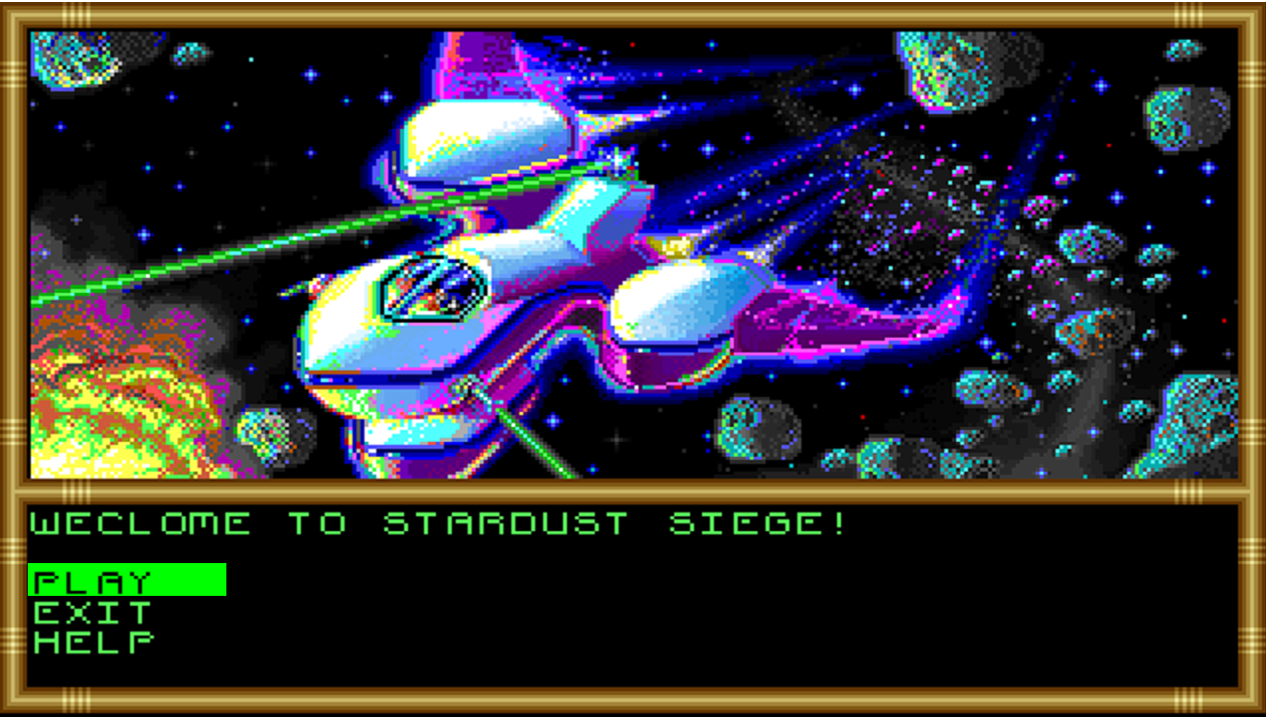

**Help Screen**

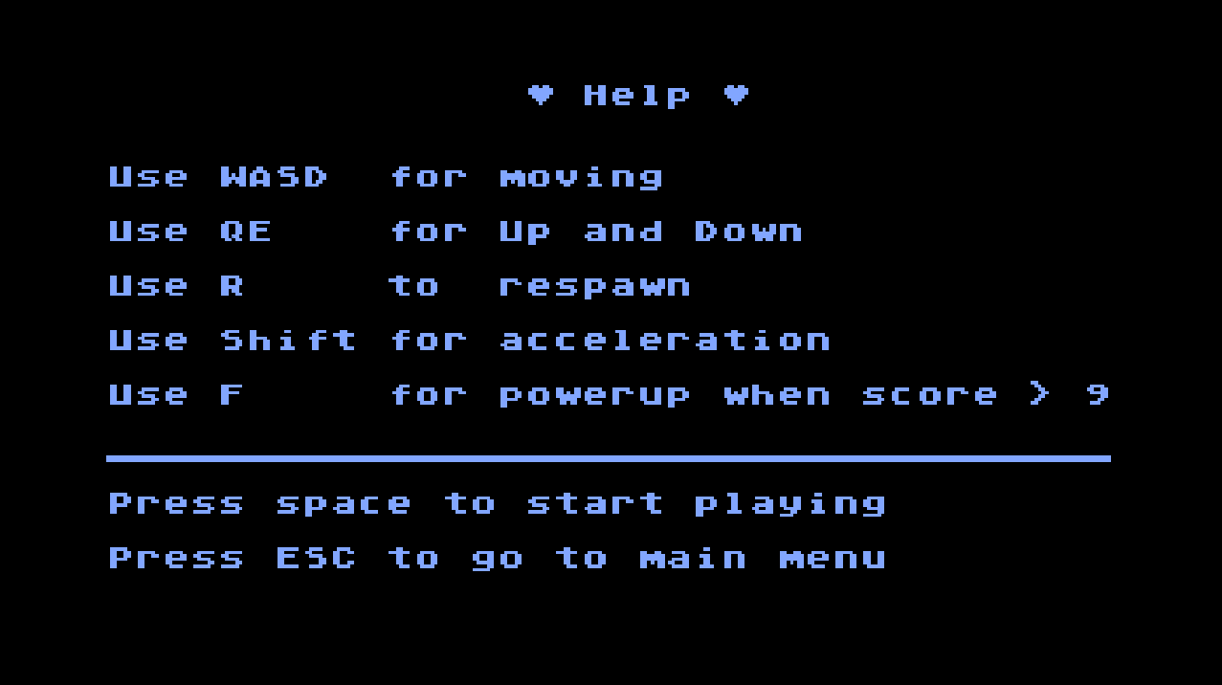

**Game**

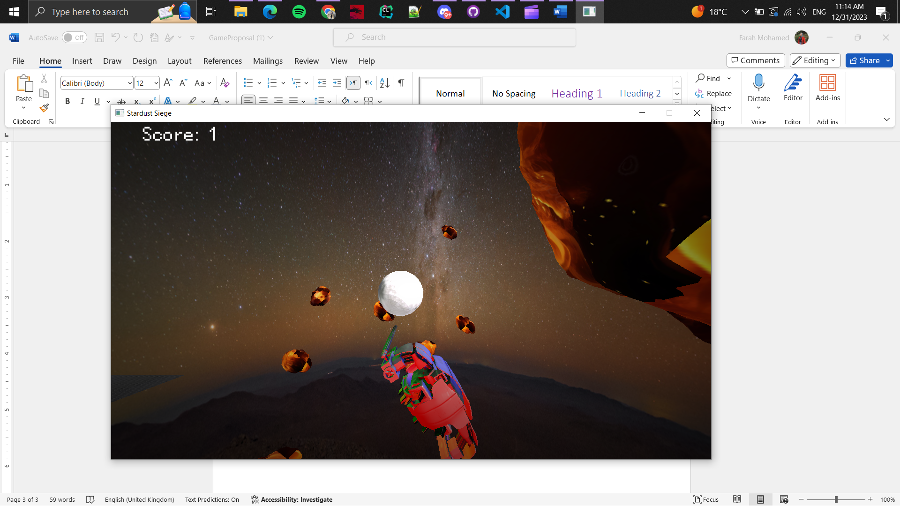

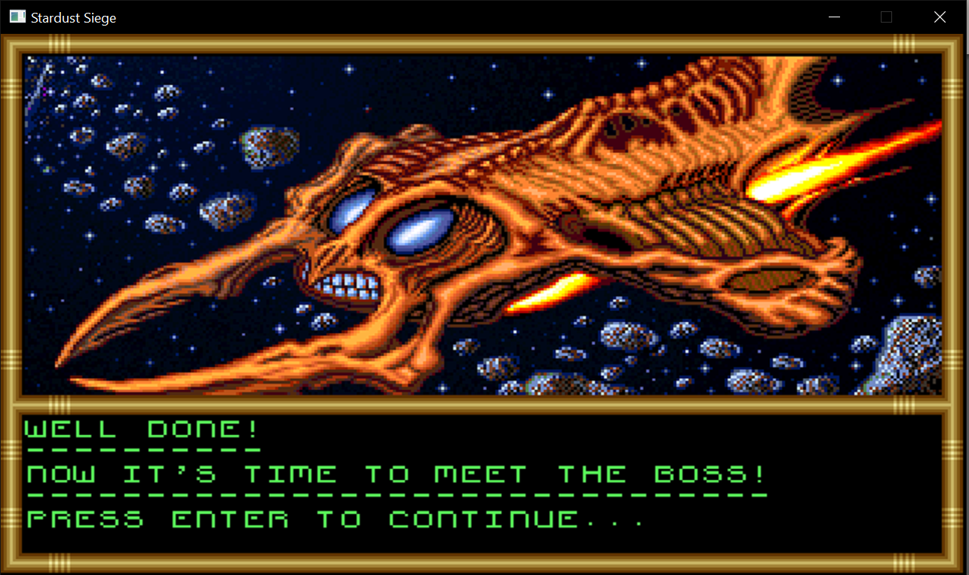**Level 2 intro screen**

**Level 2**

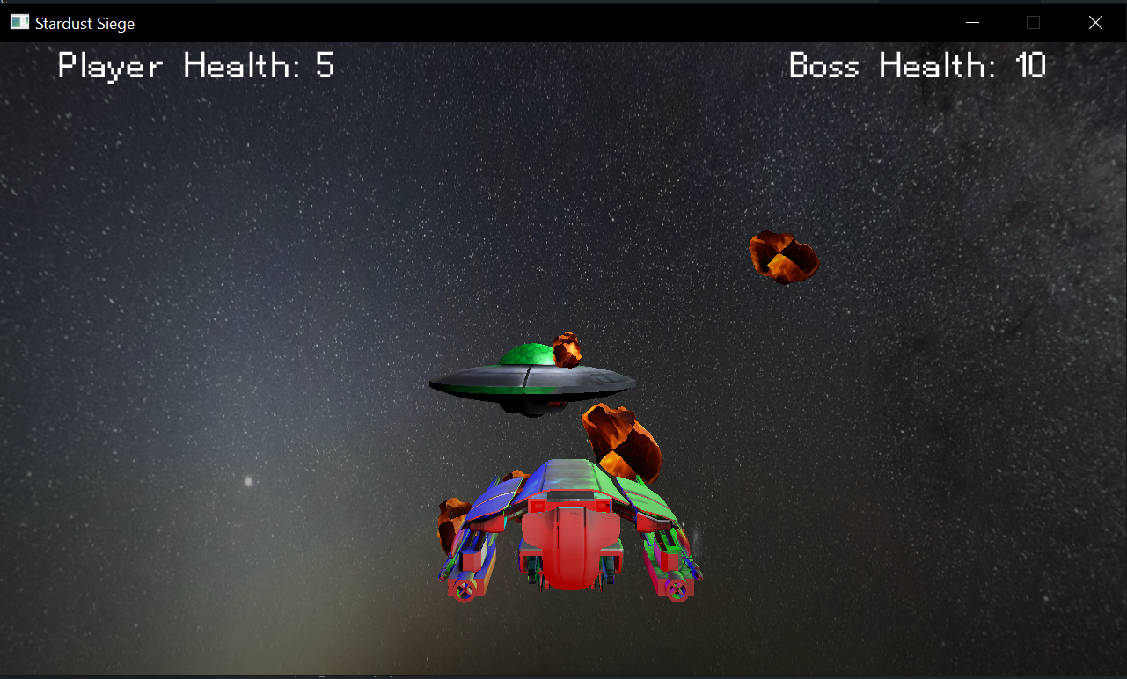

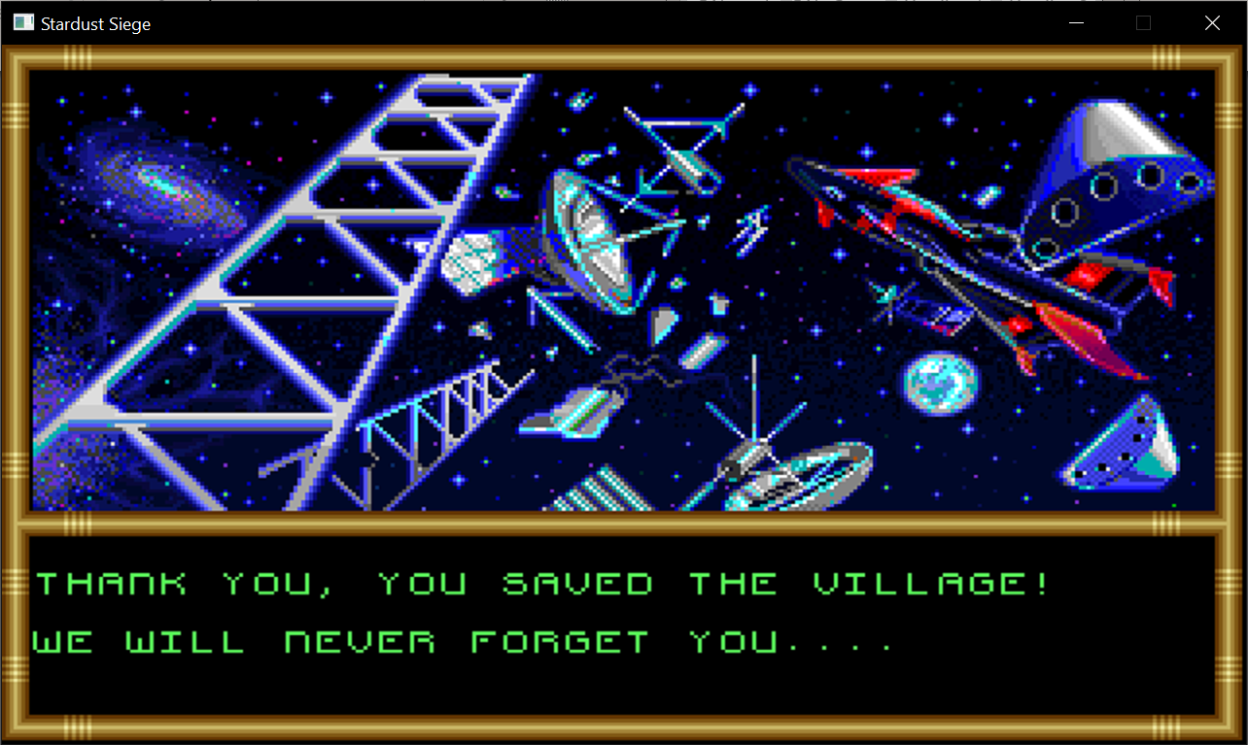**Win Screen**

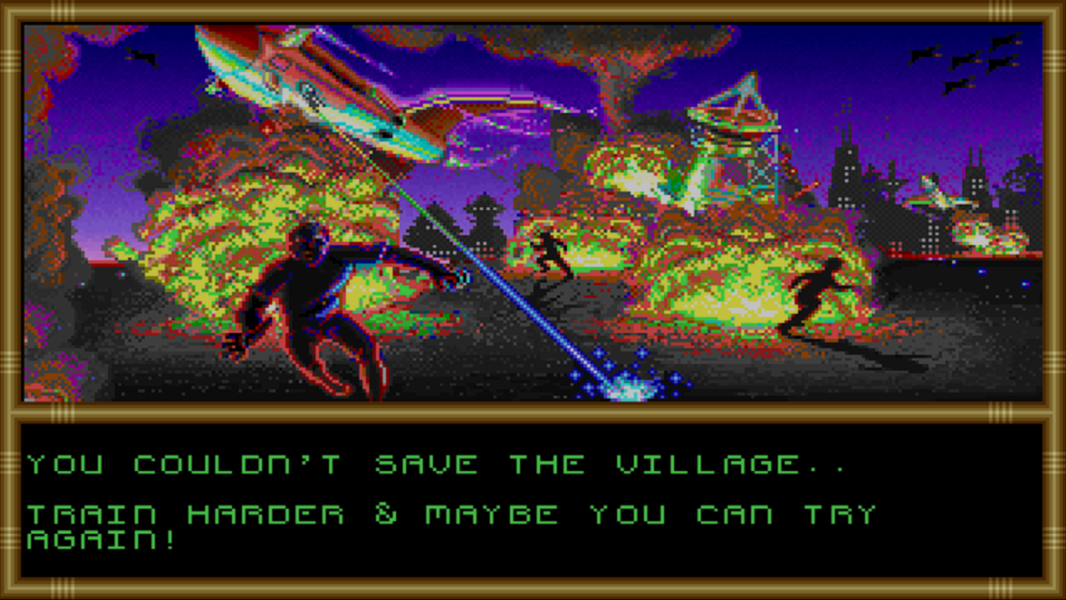**Lose Screen**

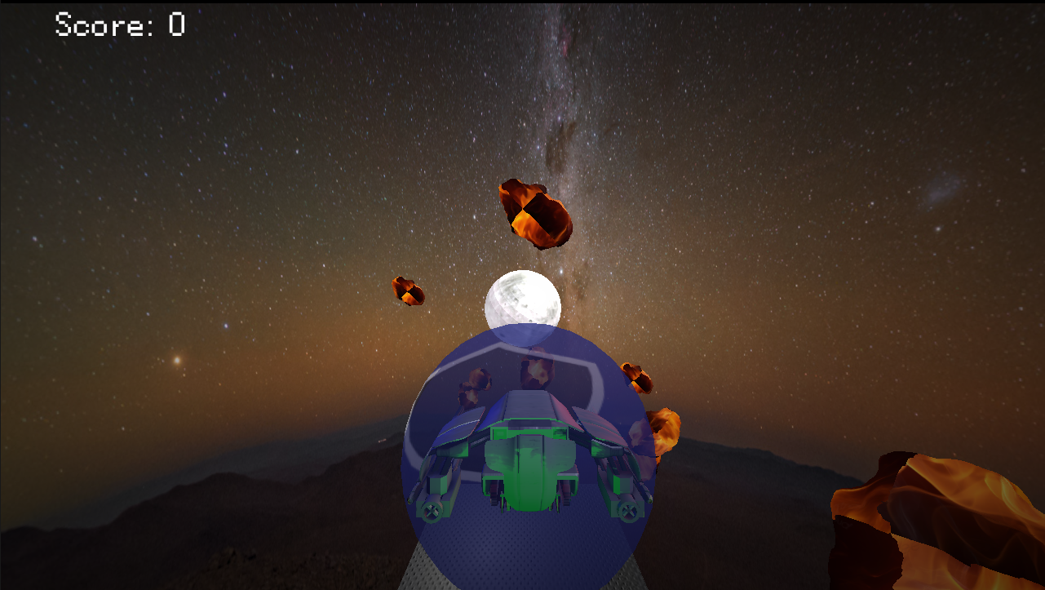**Power up**

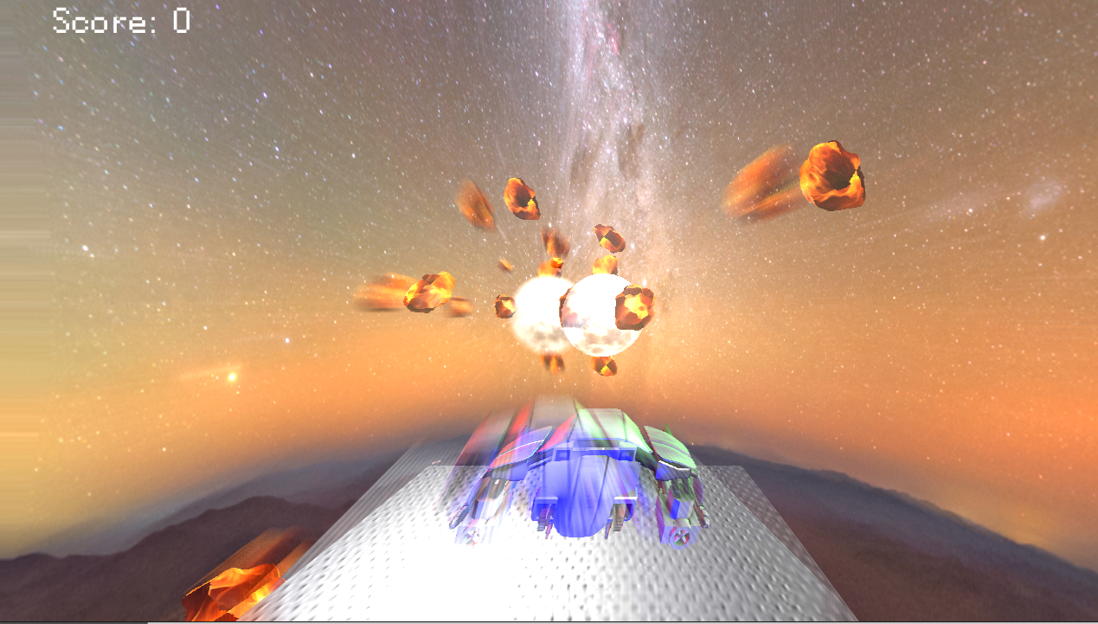**Postprocessing effect**